Application shortcuts

F11- to put into query mode

Control+f11- to execute

F4- to cancel form

Control+down Arrow- to create new record in form

Alt +F+w – to switch responsibility

Shift +F5- to copy previous row field to next row

TOAD Shortcuts

Control+enter – to execute sql statement

Shift+control+f – to format the code

F4- to describe data base object

User Creation

Responsilibty creation

Order to cash cycle –

DELL Company –

Oracle apps DBA- install oracle apps

End User

Sales representative ---

1. Order entry

Customer ,Bill to location ,Ship to location,

Item- LAPTOP,MOUSE,Key board,qty – 5,UOM- Each,unit price – 35000

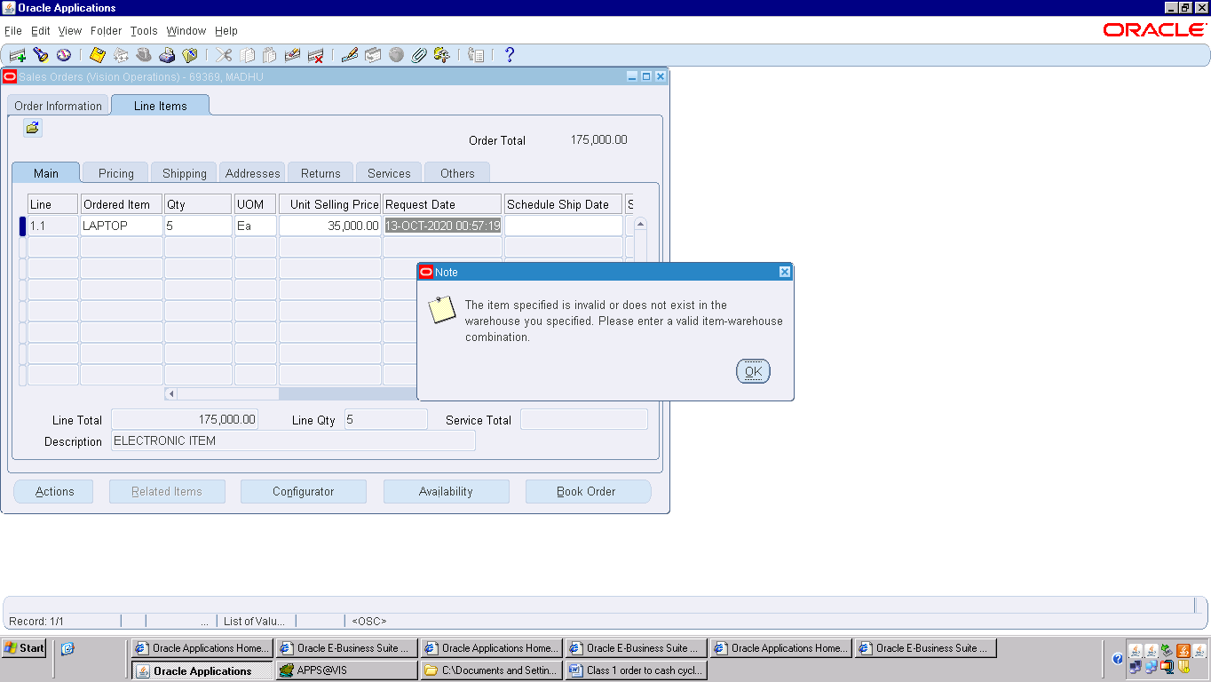

Item creation in the ware house ,means inventory responsibility

* Item creation
* Onhand qty
* Add item to the price list

Front end – oracle apps

Back end – oracle –TOAD

Order Entry – oe_order_headers_all ,oe_order_lines_all

Header_id header – entered line – entered

Booking header – booked line – Awaiting shipping

MADHU- 5 Laptops from dell

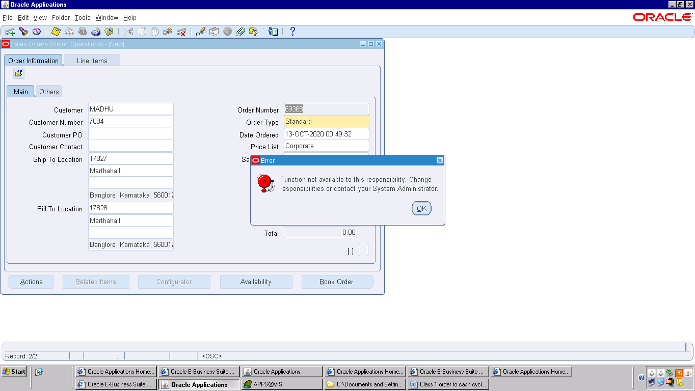

Profile name – utilities diagnostics